**Welcome to Right Track’s August 2022 Newsletter**

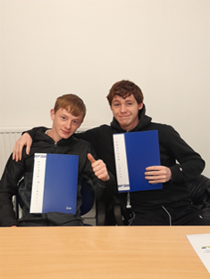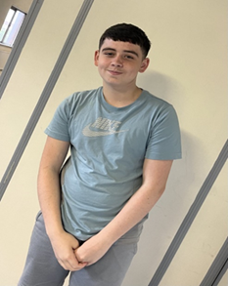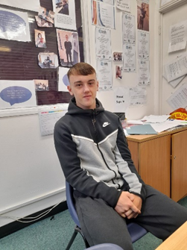

Staff Join in with the trainees having some fun …….

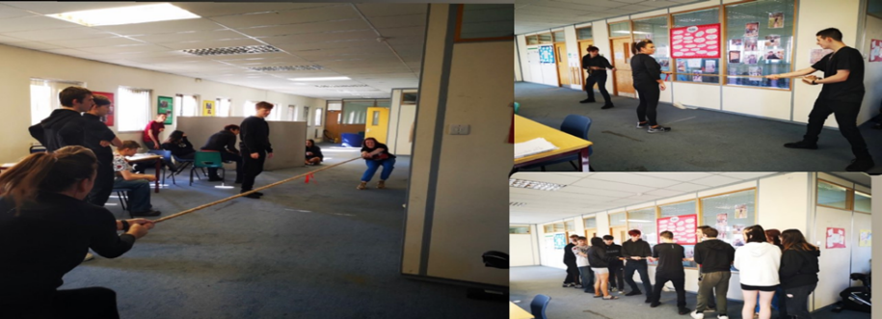

August was a very busy month! Our Lift Off participants returned after the Summer Holidays and we welcomed a new group of fifteen young people from a variety of North Lanarkshire Secondary Schools. Another 20 young people joined our Accelerate Project, and another 12 young people joined our Launchpad Programme. In addition, 10 young people started attending our REACH Mental Health Support Group. In addition, we had a lot of Touchdown progressions to College and Jobs. Great successes for our young people but our Touchdown trainees have been a great wee group, who worked really hard to help and support each other, so we are sad to see them go but wish them every success. So, a lot of starts, some farewells, and very busy Centres!

In this Month’s Newsletter we would like to share the following Articles with you.

* Some of our Touchdown Leavers
* Jobs and college places secured at the end of August
* Hall of Fame
* Lift off Progressions
* Our Ambitions
* New Starts With Right Track
* Breakfast Club
* Good day Out
* Trainee of the month

**Some of our Touchdown Leavers**

**Hayden Mcinally**

Hayden completed his Touchdown Programme this month with Right Track.  He was presented with his Record of Achievement folder to highlight all of the successful Goals he achieved during his time on the Programme.

This is a summary of his time on the programme;

* Carried out a Work Taster / took part in Work Experience Placement / went out on Employer Visit / Preparation for Training for A Qualification / achieved SQA level 4 Qualification /engaged fully in a range of Life Skills Activities / experienced

hands on V.R. activities / participated fully in Digital activities / gained Employment

Hayden now feels proficient in job search activities and has a clearer understanding of employer expectations.  We wish him every success for the future. Hayden will now take up employment at C+L Haulage and we wish him well in the job.

**Lydia Orr**

Lydia has successfully completed her Touchdown programme with Right Track. She has stated that the programme has been “banging” and really enjoyed her time with us. We wish her every success moving on to a College Course and new chosen career path in makeup artistry. We have had a lot of happy times to celebrate during the programme. We have celebrated her 18th birthday with cake and celebrations. Trainees decided to set a project to make a cat tower for Lydia’s 18th birthday gift – kitten called Binks. Everyone got stuck in to make the gift for Binks and we all enjoyed the task. She has now left to go to College for Make-up artistry.

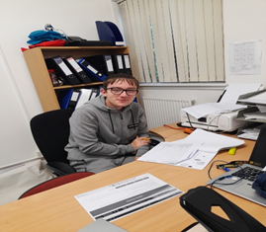**Dylan Ross**

Dylan completed his Touchdown programme after successfully gaining a place at Kelvin college for Computing. We wish him every success in his new career path. As part of our Aftercare service, we have been in touch with the College Guidance team to help support Dylan with his transition to College and they have confirmed that they are happy to oblige him.

**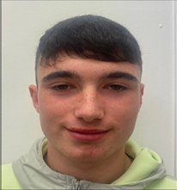****Jye Docherty** started on our Touchdown Programme with an idea of what he wanted to do but with no practical experience, as he had just left school. He was keen to gain experience in construction, so we sourced a work placement with a general building company for Jye to allow him to work alongside a variety of tradesmen. This would help Jye to make an informed choice as to what career path would be suitable for him in such a broad area of work. After successful completion of his work experience Jye decided to apply for College and gained a place at Motherwell college for City & Guilds construction, pre apprentice. We wish him every success for the future.

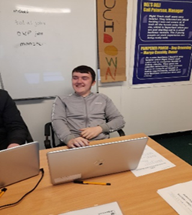**Jack Stone** was participating enthusiastically on our Touchdown programme and had been steadily achieving all the goals set for him including gaining work experience in a busy recycling plant and gaining a SQA level 4 qualification. He was really pleased with his CV and felt it was helping him gain job interviews for himself. He was waiting to hear back from one of the interviews he had been for but a chance encounter with a family friend gave him a job lead and he came into the centre the next day to tell staff about it. We wasted no time in contacting the company and after a telephone conversation they were happy to receive information about Touchdown and at their request, Jack sent off his C.V to the HR officer. It was a quick process for Jack – He sent off his C.V. on Thursday, went for an interview on Friday and started his job on Monday 😊😊 That’s the way to do it!!!!!!!

We wished **Ryan Sneddon** farewell from Touchdown and wished him every success for his College Course that he was starting the next day at Motherwell College for City & Guilds Intro to Construction. Ryan hadn’t been with us much time, but he managed to achieve an SQA level 4 qualification, First Aid qualification, build up his digital skills and experience using V.R. equipment in a vocational setting and has a clearer understanding of employer expectations, all of which he added to his C.V. Ryan is looking forward to his new chapter in life – GOOD LUCK RYAN!!!

**Jonathan (JoJo) Logan** has now completed his Touchdown programme and we wish him every success for the future. He has been issued with his Record of Achievement folder. JoJo has gained work experience with a general building company, a logistics company and in a recycling plant. He has also gained vocational training for his CSCS certificate and passed his CSCS test and was issued with the card. He has achieved a SQA level 4 qualification, along with inhouse First Aid, Digital Training and V.R. experience. All these achievements have been added to his C.V. and incorporated in his record of achievement folder to show an employer he is more than work ready. We wish him every success for the future!

**Other Jobs & College places secured**

**Jack Stone** has left the programme to take up employment with Scotcast Building Merchants. Jack was very keen for employment and is very excited for his new adventure. We wish him the absolute best and hope he enjoys this opportunity!

**Leah Sweeney** who was on our CRF Lift Off program but has now moved over to our Launchpad Pre NEET Programme and has now been accepted into College to do Makeup Artistry. During her time at Right Track Leah made new friends and came out of her shell. We wish her the best for the future!!

**Nico Potter** left us after a short period of time to go to College. Nico came to Right Track with little confidence and low experience but after time, he made new friends and made a good impression on the staff. We wish him the best luck for the future!!!!



**QUALIFCATIONS ACHIEVED IN AUGUST**

CAITLIN MCAULEY ON ESF ACCELERATE ACHIEVED HER PD SELF AND WORK.

GRACE DONNELLY ON CRF ACCELERATE ACHIEVED HER CORE IT.

DANIEL JANUSKEVIC ON TOUCHDOWN ACHIEVED HIS SKILLS FOR CUSTOMER CARE

KYLE SMITH ON CRF ACCELERATE ACHIEVED PD PRACTICAL ABILITIES

ALYSSA MCQUILLAN ON CRF ACCELERATE ACHIEVED CORE IT

CHANTELLE HARMON ON CRF ACCELERATE ACHIEVED CORE IT

TYLER WEST ON CRF ACCELERATE ACHIEVED CORE IT

RYAN SNEDDON ON TOUCHDOWN ACHIEVED SKILLS FOR CUSTOMER CARE

JACK STONE ON TOUCHDOWN ACHIEVED SKILLS FOR CUSTOMER CARE

JOHN SMITH ON TOUCHDOWN ACHIEVED SKILLS FOR CUSTOMER CARE

JAY FERGUSON ON CRF ACCELERATE ACHIEVED CORE IT

LEWIS HUTTON ON CRF ACCELERATE ACHIEVED CORE IT

DYLAN ROSS ON TOUCHDOWN ACHIEVED PD SELF AND WORK

KYLE SEDGEWORTH ON CRF ACCELERATE ACHIEVED CORE NUMERACY

ABIGAIL LINDSAY ON S2 ACHIEVED HER PD UNTITS

CHARLIE TODD ON CRF LIFT OFF ACHIEVED CORE IT

FINLAY ROONEY ON CRF LIFT OFF ACHIEVED CORE IT



**Good News – our Lift Trainees progressing to higher level Training**

Congratulations to our young people who have progressed from **Lift Off** to our **NTSF** **Launchpad Pre-NEET Programme** and have started working on their CVS and getting more focused on learning about the World of Work and what types of jobs they may like. As none of these young people can yet officially leave School, they have demonstrated their commitment to training through their Attendance levels and maturity. All doing well, keep up the good work!

So far, we have had **Jamie Penman** moving over to our Launchpad Pre NEET Jamie started on Lift Off and was very shy and did not want to participate in the group as he did not know anyone. Now Jamie has started coming in more often and has made some new friends on the programme. Jamie has overcome many barriers and we can’t wait to see what the future holds for him.

We have also had **Finlay Rooney** move over to our Launchpad Pre NEET programme. Finlay was always very outgoing and always wanted to be with the same people. Since returning he has found some more friends and is getting along better with the group he is in now. Finlay has even started asking about jobs and getting his CV ready and maybe going out on a work taster. We love to hear this from him!

**Charlie Todd** has also moved over onto the Launchpad Pre-NEET programme, and his attendance has continued to improve. Charlie has matured so much and is a lot calmer. We are seeing a big improvement and he is even thinking about his CV and jobs. We are excited to see him grow into the young man he should be.

**Leah sweeney** returned after the summer holidays after attending well pre-summer and also throughout the summer program. She then found out she had been successful in securing a College Place. We are so exited for Leah and hope this works out for her as she is such a lovely girl. Well done, Leah!!!

**Arron Fagan** returned after the summer holidays and also moved over to Launchpad. Arron has worked well with staff, and he is progressing well to becoming ready to go out and work. There is a huge improvement in Arron and that is what we like to see!!



**Our Ambitions**

**At Right Track a large part of what we do is support young people to have raised aspiration and to learn more about the opportunities they could experience. We encourage young people to follow their dreams and try and provide access to the practical steps needed to achieve them.**

**Kyle Smith** – Kyle Smith who is with us on the Accelerate Programme really likes trains. When he started he was very quiet and shy, but he has really come out of his shell and has made loads of new friends. Kyle is interested in working on trains and would be happy to do anything with them, but his main goal is to be a train driver.

**Dean Cummings** – Dean Cummings is on our Accelerate Programme and was very quiet, when he first started and didn’t socialise much. Now Dean is socialising a lot more and has made loads of new friends. Dean has explained that he would like to gain Work Experience to help him become an electrician.

**Leo Gurie** – Leo Gurie is on our Touchdown CRF Programme and is interested in a career in Hairdressing. Leo is currently looking at different College Courses and doing research to help him find out things that may help him with this career. Leo Is very quiet but he has made a lot of friends and did extremely well on his Work Experience Placement.

**Finlay Rooney** - Finlay Rooney is on our Launchpad Pre- NEET Programme and would like an opportunity to work on a building site. As he is only 15 and doesn’t have a CSCS card he is keen for a Work Experience Placement to guide him in the right direction and gain experience to see if this is what he really would like to do.



**New Starts at Right Track**

**Reece Gorman** started with us on CRF Accelerate in August has said that when starting with Right Track he didn’t know anything about it and was looking for support. Reece says now he is enjoying it and is a good place to be. He has made loads of new friends and finds it very helpful. Reece says it is setting him up for the future. He is currently working on his CV with Joan and is exited for all the opportunities that he is going to gain from attending the centre.

**Kyle Smith** who started with us on our CRF Accelerate programme in June said that when starting right track he didn’t really know what to expect about he was going on. He has now come out of his shell and said he really enjoys coming into the centre and is so glad he has taken advantage of the opportunity to attend and the help we are giving him.

**Kayden Toal** started on our REACH Support Group in August and thought attending here would be like school and didn’t think it would help as much. Now Kayden is excited to attend and finds it fun, which has completely changed his mindset. Quote from Kayden, “it is pretty banging here”

**William McGlynn** who started on our REACH Support Group in August heard about Right Track and was exited as he was told that the Project would not be in a school environment. William said, “best place ever” and even complimented our cheese toasties!**A group of people in a room
**

**Breakfast Club**

At Right Track we offer a hot breakfast and lunch to all Project participants. Young people are supported to work with staff – mainly Amyjane and Kaitlin, to help make the breakfasts and lunches. Eating is pretty popular, cleaning up is less so!!

This year we have introduced the use of air-fryers and George Forman grills and soup-makers alongside our ever-popular toastie and panini-makers!

Lunches are varied including burgers, wraps, toasties and paninis, pasta, chicken wings, pizza etc and chips of course! Although these are much healthier made in the air-fryer!!

Preparing our own breakfasts and lunches has proven to be much cheaper and ensures that our young people not only have hot food during the day, they are also eating healthier options. Many of our young people struggle with eating in public for a variety of reasons and many have very restricted experiences of eating well. The provision of breakfasts and lunches is of huge value to our young people and a large part of what we do is introducing young people to new eating options. This is a hectic but hugely beneficial part of our days!

*Kayden, “it is pretty banging here”!*

**A Good day Out!**

When asked about what they thought had been a good day out today, trainees said one of their favourite trips had been a trip to Balloch Park.

They all agreed that they enjoyed making new friends and bonding with the other young people on different Programmes. The trainees pointed out highlights as cooking burgers for lunch and the team games they played.

**Sometimes the simple things are the best!**

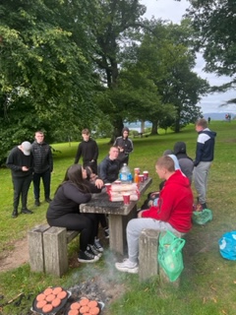



[This Photo](https://pchujman.cumbresblogs.com/2020/08/07/songs-to-protest/) by Unknown Author is licensed under [CC BY](https://creativecommons.org/licenses/by/3.0/)

**TRAINEE OF THE MONTH**

**NICO POTTER – CRF ACCELERATE**

**Our Wee “charmer”**

Nico started on our Accelerate Programme on the 26/06/2022. At first Nico’s attendance was very low but then he started to enjoy the Centre and the Project more and made loads of friends. Nico smashed all his Barriers and Personal Goals and completed a Qualification while only being here for a short period of time.

Trainer, Joan said the first time she met him that he was a “wee charmer”. Nico also had amazing problem-solving skills and always tried to motivate others and help his team mates out. He was with us for a short time before going to College but said we helped him “grow in confidence” and “calm down a bit”.

We are wishing Nico the best for his College experience and all the best for what the future holds for him. He has a lovely attitude and personality so we are sure he will do well.



**This project is part funded by the UK Government through the**

**UK Community Renewal Fund**

*The UK Community Renewal Fund is a UK Government programme for 2021/22. This aims to support people and communities in need across the UK to pilot programmes and new approaches to prepare the UK for the Shared Prosperity Fund. It invests in skills, community and place, local business, and supporting people in employment. For more information, visit* [*https://www.gov.uk/government/publications/uk-community-renewal-fund-prospectus*](https://www.gov.uk/government/publications/uk-community-renewal-fund-prospectus)

