Welcome to our January 2023 Newsletter……
November and December of 2022 were a really busy time at Right Track and unfortunately, we ran out of time to send out our usual monthly Newsletter. We have decided to issue the first Newsletter of 2023, as a “catch-up”, noting some highlights, some news and some goodbyes.
The period October to end December 22 saw the launch of our first North Lanarkshire Council No One Left Behind Projects; Lift Off and Accelerate and FOCUS. These Projects were a follow-on from our successful Community Renewal Fund Projects that we had delivered between November 21 and end September 22, again in partnership with North Lanarkshire Council.
The transition between funding streams was a challenging time for everyone but with huge support from our Partners; North Lanarkshire Council, SDS Careers, local Secondary Schools, other Training Providers, our staff team and many Parents and Guardians we are delighted to say all three initiatives are off and running with over 70 participants by the end of December 22!
October to December was a bit of a rollercoaster for everyone with many exciting activities taking place, not least Halloween, Guy Fawkes and Christmas!
“Pin the Ears on the Vampire” was a particularly popular activity….. I do not think the “vampire” ran fast enough!! “Speedy Spiders” was also popular, just not with the staff who are particularly phobic about our many-legged little friends!
Halloween sweets and pumpkin carving were also popular and making decorations was great practice for the Christmas period. Bridgeton’s candy apples were particularly good!
Christmas brought with it the usual festivities, with young people making gift baskets and their own Christmas decorations. The amount of chocolate in Centres increased about 100%! Apparently, the new Christmas movie “Spirited” was “brilliant” and there were many others. “Back to the Future” movies remain ever popular too although some of the team are feeling really old as we remember when they first came out! There was also a level of surprise in some quarters that outdoor activities also took place in the winter……yes, it was cold, but it was all about taking part!!
December, sadly, also saw the end of our National Third Sector Employability Fund Projects after an extended partnership with SCVO and SDS. Right Track achieved a near perfect 100% Compliance record in the delivery of these Projects, but we could not have made the Programmes the success they were without the dedication of our partners and commitment of our staff team. We would like to extend our sincere thanks to SCVO and SDS, particularly Barbara and Gary. Our NTSF Projects allowed us the opportunity to show that young people learn in many different ways and that varied, activity-based Programmes, with clear progression routes facilitate tangible and sustainable outcomes with even the most challenged young people. NTSF funded Right Track’s Stage 1, early intervention provision and were a clear investment in the successes young people achieved in College, Employment and Vocational Training in future Programmes.
We look forward to the introduction of the UK Government’s Shared Prosperity Fund as a replacement for ESF funds in the near future.

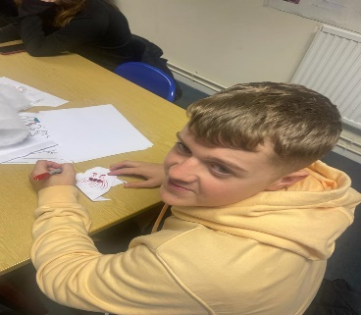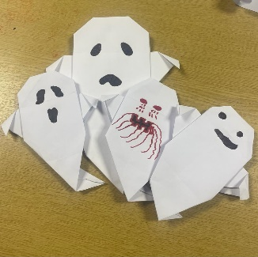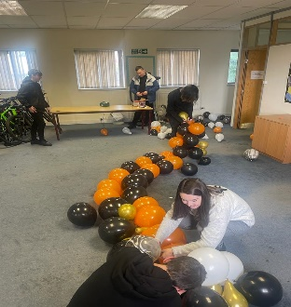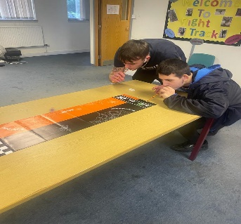
Contents
- REACH
- Some Good Days Out
- Case Studies
- Attendance levels and Soft Progressions
- Placement activities
- Hall of Fame
- An Exceptional Trainee

REACH
Our REACH mental health support groups were piloted in August last year. REACH was launched in response to the number of young people being referred to us who could not flourish within even our most basic Programmes.
Young people referred to REACH are often “non-verbal”, are completely withdrawn, have issues with self-harm, body dysmorphia, gender identification, they struggle to leave the house, feel depressed and anxious, have undiagnosed learning difficulties or autistic spectrum disorders, are suffering from extreme grief following loss of a loved one, or are just young people with an expectation of failure and absolutely no understanding or acceptance of self-worth. In general, they see no future and no place for themselves in any form of success.
We are not qualified mental health practitioners. We do however have extensive experience in working with particularly disadvantaged young people aged 15-18 years and we know what experiences and supports help young people to start feeling better about themselves.
The overriding aim of the Project is to support the young people described above to feel better about themselves and their future, as a result of highly supportive REACH provision. Staff describe REACH as “a big hug” and indeed this is an apt description.
Through REACH support we want young people to feel listened to, cared for, understood, supported, encouraged, and nurtured. Through REACH support we want them to attend the Project, communicate and make friends, open up, and learn coping skills. Ultimately however we want them to feel better, happier, included and more positive.
REACH is largely groupwork enhanced by one to one support and activities aimed at confidence building and developing communication, self-esteem and personal resilience, alongside challenging barriers and trying something new.
REACH includes supports such as CBT Practitioners and other guests, health and fitness activities, alternative therapies, arts and crafts, music, visits, outward bound, cooking, community projects, make-overs, cinema, sports introductions, all things designed to make young people feel good, and in doing so, improve their circumstances. Staff have extensive contact with parents/ guardians and in many ways, they are beneficiaries of REACH too. Home visits take place regularly and for many young people we need to collect them from home in the morning as they simply do not have the confidence or support to leave the house or travel independently.
Right Track’s approach in all things is; “small steps “, “softer progressions”, lead to the achievement of longer-term sustainable goals. REACH represents this fully. It is a starting point. Feeling better about yourself makes you more able to consider other changes and better able to address sometimes very real challenges.
We now offer REACH in Glasgow and Coatbridge thanks to recent donations from the Hugh Fraser Foundation, Robertson Trust and Agnes Hunter Trust. Our participant groups are kept very small but both groups have gelled well, and we have already had a couple of young people who have managed to progress to our Lift Off and Accelerate and Launchpad Programmes after making real progress.

Good Days Out
Our REACH mental health support group and Launchpad participants recently took part in a day out they really enjoyed. Nobody was initially very enthusiastic about the thought of indoor crazy golf but all were reminded it was about having an open mind and trying something new……..
However, everyone loved it, and it was obvious on the day that Jamie and Nikola had become great friends and enjoyed helping each other, a great result! They even got a wee bit competitive with each other and loved their day out….that’s what it is all about!
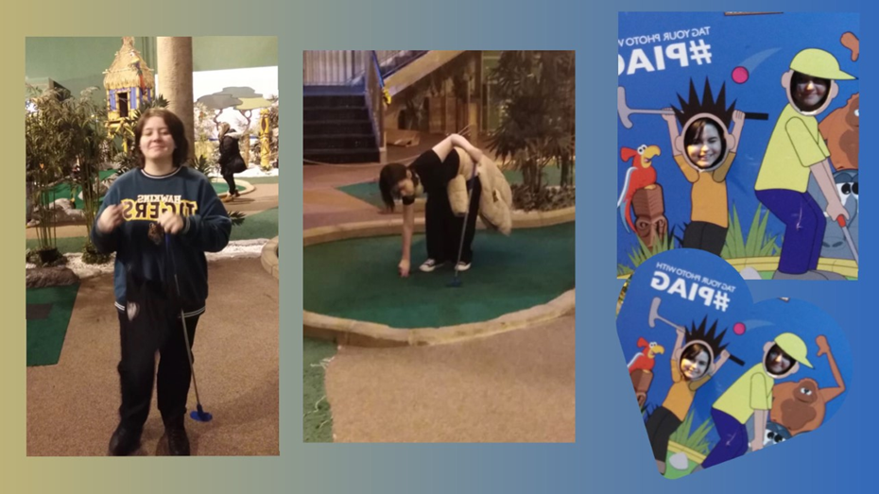
Practice makes perfect……I’m told!
This was the first of quite a few groups who have enjoyed the indoor crazy golf. While not really a team sport, It is a great activity for communication, encouraging others, following advice and most importantly, perseverance!!
Winter days out!
The winter months do not stop us getting out and about!

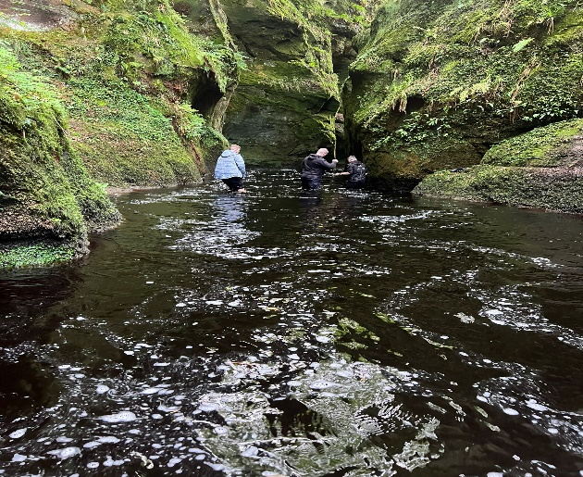
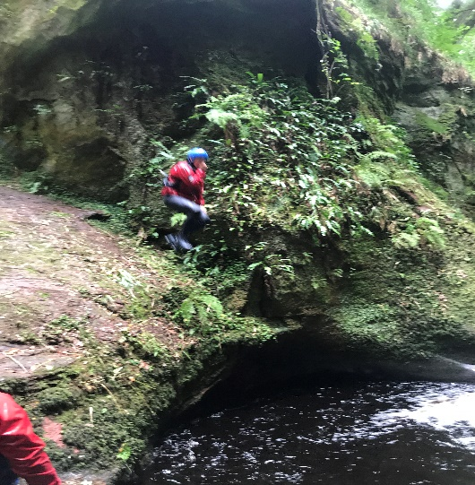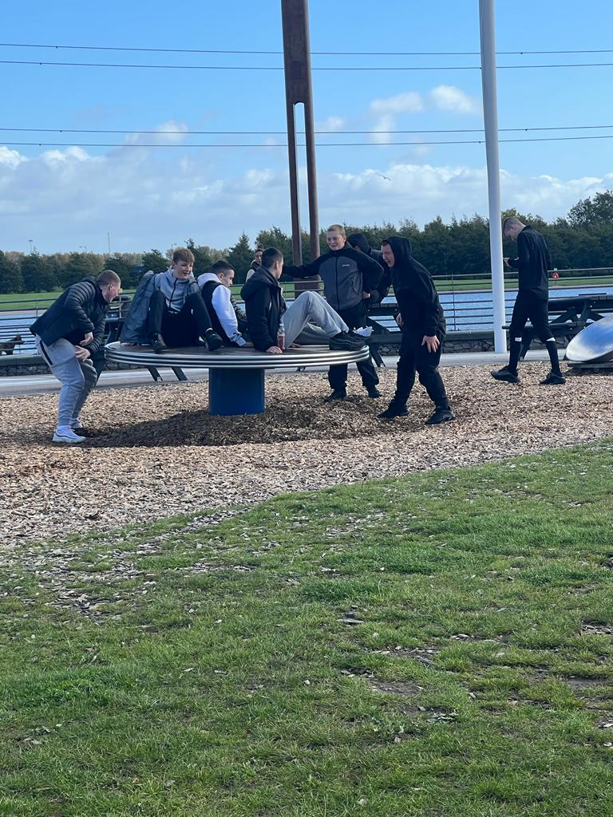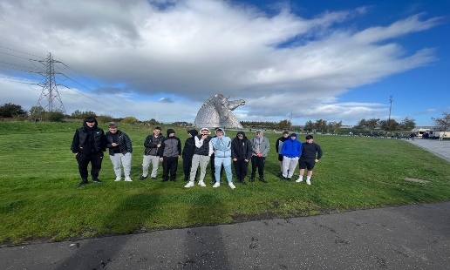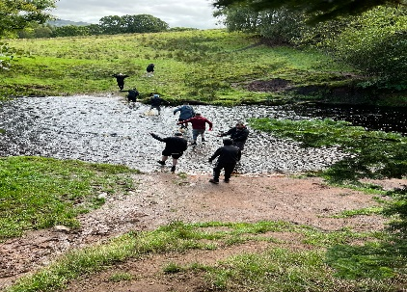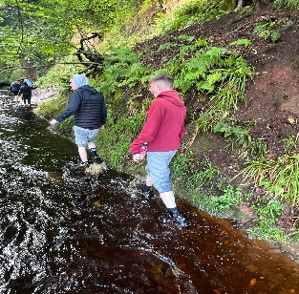
Case Studies – No One Left Behind - FOCUS
“Craig”
Craig came to Right Track when he left school in June of 2022 after he had finished his sixth year. He was extremely quiet and not very sociable. Craig had been attending school but throughout the pandemic his feelings of anxiety had increased and he has stopped socialising with peers.
Craig admitted to being nervous about coming into centre and meeting new people. We agreed with Craig that it was a priority for us to work with him to improve his confidence and communication skills as he was not ready for Work Experience or applying for jobs
Craig took all of this on board and tried hard to make new friends . He soon became more sociable and confident while talking to staff and other young people.
At the beginning of October Craig felt ready to move to our FOCUS programme which was much more employability focussed with training sessions on employer expectations and workplace skills. Craig worked with staff to develop his first CV and he received one to one support with jobsearch activities. He registered with numerous job websites and learned how to apply in the correct manner. Craig ahs made real progress and is much more confident and motivated. Craig will shortly be progressing to Work Experience. He likes to stay in a routine and is always early to start the day so we are taking that into account in selecting Work Experience opportunities. Craig has made real personal progress even when sometimes things have been a challenge for him, he has pushed himself. He has always persevered and has really moved outwith his comfort zone. We are really proud of him and positive about his future.
“Liam” – NOLB Accelerate
Liam started with us on NOLB Accelerate on the 03/10/2022. When he came into the centre, he had a lot of confidence and was not shy at all around staff and his peers. He had few Qualifications however and limited interested in taking part in work related to Qualifications. While being here he has participated wholeheartedly in many group projects but particularly enjoyed the practical tasks including painting and decorating the Accelerate room.
Liam gets along with everyone in the centre and loves to have a chat. He is very personable with great social skills, something we have been keen to point out to him is a huge employability skill. Liam has made great progress, no recognising the value of learning. He is now willing to try anything and has already achieved his ICT level 4 Qualification. He is working hard on his Employability Skills and has started to think what he would like to do with his future. He is currently getting one to one support with his CV and help with looking at Colleges and Apprenticeship options. Liam had a Saturday job before coming to Right track and this helped him see that he would be interested in careers such as joinery and landscaping, so he has been researching about these sectors and learning what qualifications he would need for this and the skills that Employers would be looking for.
We are proud of how far Liam has come due to his lack of qualifications and initial lack of interest in Qualifications. He is now eager to get out on Placement and is very positive about gaining real Work Experience and an Employer Reference. Liam has matured, in a short time, and we hope he secures a job soon.

Young People in Work Experience
Work Experience is a key element of our Stage 2/3 Programmes. It is an opportunity for young people to “test” their skills in real work environments. Feedback from Employers is invaluable. It helps identify ongoing development needs as well as particular aptitudes. It also gives an Employer the opportunity to “trial” a young person who possibly does not have the entry level skills or experience that they may usually ask for. Importantly it also provides young people with a reference from an Employer to add to their CVs, something other Employers value.
Our request of Employers is to offer a range of Work Experience opportunities;
- A visit
- A short-term “taster” – a few days or weeks
- Longer-term Work Placement
- A Work Trial
On average 45% of the jobs young people secure, come from Work Experience Placements where often there was no expectation of a vacancy.

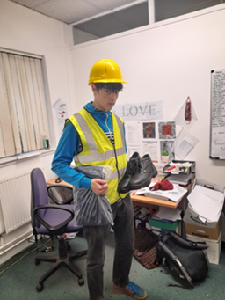
Trainees In Placement
Rowen Anderson who recently joined our NOLB FOCUS Project went out on a Work Trial and totally “smashed it !. Rowen was really enjoying the Placement and was even coming into centre after work. Rowen was in Placement at Henry Waste Management at Coatbridge and after Work Trial was offered the job. Rowen did really well and was absolutely delighted. We are so proud of you Rowen and we wish you the best in the future.

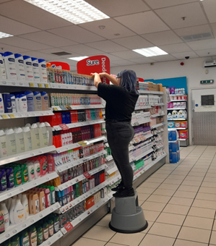
Louise Weir who took part in our NOLB FOCUS programme started Work Experience in SAVERS. Louise enjoyed this Placement and learning all about retail. Following this, Louise was successful at securing a College Course at Motherwell College but chose to start a job instead at a new ice-cream shop called Tubbee’s in Coatbridge. Well done, Louise!
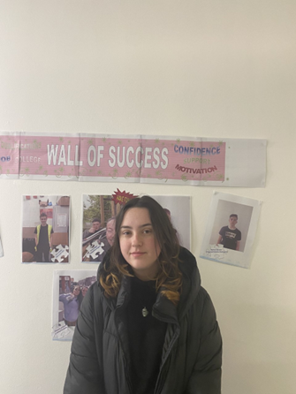
Alyssa Mcquillan also recently started on our NOLB FOCUS programme. She first undertook Work Experience in DEBRA to gain some experience in cash handling and card payments. Alyssa suffered from anxiety so this was a big step for her but she did really well and got great experience. She then started Work Experience at a new Placement, Fish Keepers Scotland. This was very out of her comfort zone, but she was looking forward to learning new things and trying new things. Alyssa would really like to work in Pets at Home, so she is continuing her jobsearch and gaining more experience while she does this.
Trainee Attendance and Soft Indicators
Key indicators of the success/ relevance of Right Track Projects are the weekly attendance levels, something we monitor each week, for each Project and for each young person. This is important as if young people are bored, do not see the relevance of Project content, do not feel included or safe, they tend to vote with their feet – attendance deteriorates and drop out can happen. This is obviously something we want to avoid and where attendance does dip it can often be an indicator of something else happening in the young person’s life and we can proactively address this.
Attendance levels are calculated weekly and are shared with staff and young people. Our current Attendance levels for Lift Off and Accelerate is 93% and for FOCUS, 97%. While these figures fluctuate weekly, they are always over 90%.
In addition to the above we also monitor over 60 “soft indicators” or changes that we hope to support young people to achieve. This ranges from simple things such as how confident, happy or motivated young people might feel but also include what we refer to as “key indicators”. These include;
Before RT Now
Value of learning | 30% | 70% | Key Indicator
Skills to get a job | 12% | 88% | Key Indicator
Confidence in the future | 30% | 70% | Key Indicator

The figures above are taken from a random sample of young people currently on our Programmes. Some will be relatively new, and others will be on exit paths.
A small selection of “soft measurements” we monitor include;
Indicator | No change | Improved
Happiness | 25% | 65%
Confidence | 33% | 77%
Motivation | 37% | 53%
Attendance | 20% | 80%
Time-keeping | 47% | 53%
Acceptance of criticism/advice | 32% | 48%
Knowing where to get help | 35% | 65%
Self-belief | 42% | 68%

Hall of Fame
STAGE | CENTRE | Name | Date certificated | Awards
ESF LP | COATBRIDGE | ABBIE INGLIS | 07/11/2022 | NUMERACY
ESF LP | COATBRIDGE | DARRIN GIBBONS | 07/11/2022 | Core I.T.
ESF LP | COATBRIDGE | JAMIE PENMAN | 22/11/2022 | Core I.T.
ESF LP | COATBRIDGE | MATTHEW GRAY | 08/11/2022 | NUMERACY
ESF LP | COATBRIDGE | ARRON FAGAN | 06/12/2022 | COMMUNICATION
ESF LP | COATBRIDGE | CHARLIE TODD | 07/11/2022 | NUMERACY
ESF LP | BRIDGETON | JACOB CONWAY | 22/11/2022 | Numeracy
ESF LP | BRIDGETON | KAYLA GILMOUR | 22/11/2022 | Numeracy
ESF LP | BRIDGETON | COLE JACKSON | 08/11/2022 | NUMERACY LEVEL 3
ESF LP | BRIDGETON | EMILYLEE ORR | 07/11/2022 | NUMERACY LEVEL 4
ESF LP | BRIDGETON | JAMIE BROWN | 22/11/2022 | Core I.T.
ESF LP | BRIDGETON | SHANAI GILES | 21/11/2022 | Core I.T.
ESF LP | BRIDGETON | KELSEY JACKSON | 21/11/2022 | Core I.T.
ESF LP | BRIDGETON | KELSEY MCCOLL | 21/11/2022 | Core I.T.
ESF LP | COATBRIDGE | CHRISTOPHER MCNAUGHT | 14/11/2022 | CORE I.T.
ESF LP | COATBRIDGE | ANDREW BAIGRIE | 29/11/2022 | Core I.T.
ESF LP | BRIDGETON | DAVID RIDDELL | 21/11/2022 | core I.T.
ESF LP | BRIDGETON | CASEY O'NEILL | 21/11/2022 | core I.T.
ESF ORBIT | COATBRIDGE | LEWIS HUTTON | 06/12/2022 | CUSTOMER CARE
ESF ACC | BRIDGETON | DYLAN CORNS | 21/11/2022 | self and work
ESF LP | COATBRIDGE | DYLAN MCINTOSH | 21/11/2022 | practical abilities
ESF ORBIT | COATBRIDGE | COREY DAWSON | 06/12/2022 | CUSTOMER CARE
ESF LP | BRIDGETON | GEMMA BLAIR | 10/01/2023 | self and work
NOLB ACC | COATBRIDGE | LEWIS HUTCHESON | 21/11/2022 | Core I.T.
NOLB ACC | COATBRIDGE | CHRISTOPHER SMITH | 06/12/2022 | numeracy
NOLB ACC | COATBRIDGE | REECE GORMAN | 29/11/2022 | Numeracy
NOLB ACC | COATBRIDGE | KEVIN MILES | 20/12/2022 | numeracy
ESF LP | BRIDGETON | KENZY CHARLETON | 10/01/2023 | self and work
NOLB LO | COATBRIDGE | LEE WRIGHT | 10/01/2023 | Core I.T.
NOLB LO | COATBRIDGE | ADAM CASSIDY | 21/11/2022 | Core I.T.
NOLB ACC | COATBRIDGE | KEIRAH FRASER | 06/12/2022 | Core I.T.
ESF ACC | BRIDGETON | AIDEN KERNACHAN | 10/01/2023 | self and work
ESF ACC | BRIDGETON | KIERAN STEWART | 10/01/2023 | self and work
ESF ACC | BRIDGETON | DYLAN HAY | 10/01/2023 | self and work
NOLB FOCUS | COATBRIDGE | KYLE SEDGEWORTH | 20/12/2022 | preparing to work
NOLB FOCUS | COATBRIDGE | ROWEN ANDERSON | 22/11/2022 | preparing to work
NOLB FOCUS | COATBRIDGE | KYLE SMITH | 20/12/2022 | preparing to work
NOLB FOCUS | COATBRIDGE | ALYSSA MCQUILLAN | 10/01/2023 | numeracy
NOLB FOCUS | COATBRIDGE | GRACE DONNELLY | 20/12/2022 | preparing to work
ESF ACC | BRIDGETON | THOMAS BUSBY | 10/01/2023 | self and work
NOLB LO | COATBRIDGE | HAYDEN EVANS | 10/01/2023 | numeracy
NOLB ACC | COATBRIDGE | TJ (THOMAS JAY) FEENEY | 10/01/2023 | Core I.T.
NOLB FOCUS | COATBRIDGE | AIDEN HUGHES | 20/12/2022 | preparing to work
NOLB LO | COATBRIDGE | ELLIE MAUGHAN | 06/12/2022 | practical abilities
NOLB LO | COATBRIDGE | AARON BYRNE | 06/12/2022 | practical abilities
NOLB LO | COATBRIDGE | ANDREW BAIGRIE | 06/12/2022 | Numeracy
NOLB LO | COATBRIDGE | MATTHEW GRAY | 06/12/2022 | practical abilities
NOLB LO | COATBRIDGE | ARRON FAGAN | 06/12/2022 | practical abilities
NOLB LO | COATBRIDGE | FINLAY ROONEY | 06/12/2022 | practical abilities
NOLB LO | COATBRIDGE | CHARLIE TODD | 10/01/2023 | practical abilities
NOLB LO | COATBRIDGE | ABBIE INGLIS | 24/01/2023 | Core I.T.
NOLB LO | COATBRIDGE | DARRIN GIBBONS | 10/01/2023 | Numeracy
NOLB LO | COATBRIDGE | CHRISTOPHER MCNAUGHT | 10/01/2023 | numeracy
NOLB FOCUS | COATBRIDGE | LEWIS HUTTON | 21/11/2022 | Core I.T.
NOLB FOCUS | COATBRIDGE | COREY DAWSON | 29/11/2022 | core I.T.
NOLB LO | COATBRIDGE | MORGAN DONALD | 06/12/2022 | COREI.T.
ESF LP | BRIDGETON | KYLE MCCAFFERTY | 10/01/2023 | CORE I.T.
ESF ACC | BRIDGETON | KAYLEIGH MILNE | 10/01/2023 | SELF AND WORK
NOLB ACC | COATBRIDGE | LIAM GRIFFITHS | 10/01/2023 | SELF AND WORK
ESF LP | BRIDGETON | RIHANNA ARIES | 10/01/2023 | core I.T.
ESF LP | COATBRIDGE | KAYLEIGH MCCLUNG | 10/01/2023 | numeracy

This Photo by Unknown Author is licensed under CC BY-SA
Trainee of the month - BRIDGETON
Cassie Caven

Cassie started with Right Track on our Accelerate Programme. Cassie had significant anxiety issues which were holding her back. Evidencing this, it took 3 attempts to get Cassie to come for an interview and when she finally came, her Action for Children worker had to basically push her into The room!
She was very nervous throughout the interview, but managed to agree to give us a chance and start the Programme. The first couple of weeks Cassie’s mum had to bring her to the door and support her to come in but Cassie soon started talking to one of the other girls who also suffers from anxiety and they became friends.
Cassie started to attend the centre herself which was also a big achievement for her. Over the weeks Cassie was getting less anxious and more comfortable. Via session discussions about potential jobs Cassie said she was interested in childcare
We helped Cassie to fill out an application to Carousel Training. She applied online and the following day Cassie got a reply asking her to come in for an interview . We helped Cassie to prepare for interview and to compile her Personal Statement, which she practiced really hard. Cassie did so well at interview that she was offered an Apprenticeship! Carousel set up a Work Trial with a nursery and she successfully secured the job. Cassie has come a long way and she has done extremely well. We cannot believe the difference in her!
To obtain more detailed information about any of the Projects detailed above, please contact Ann Neary or Tracy Burns on 01236433315 or by email; annen@rtscot.co.uk/ traceyb@rtscot.co.uk

