**Welcome to our October Newsletter……**

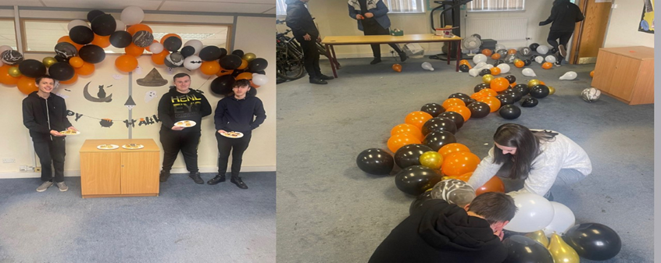

**Let’s have a catchup and see what has been going on in our centres.**

**Contents**

1. **Halloween activities**
2. **Good days out**
3. **NOLB CASE STUDIES**
4. **Partnerships**
5. **Trainees in placement**
6. **Hall of fame**
7. **Trainee of the Month Coatbridge**
8. **Trainee of the Month Bridgeton**

**Halloween Activities**

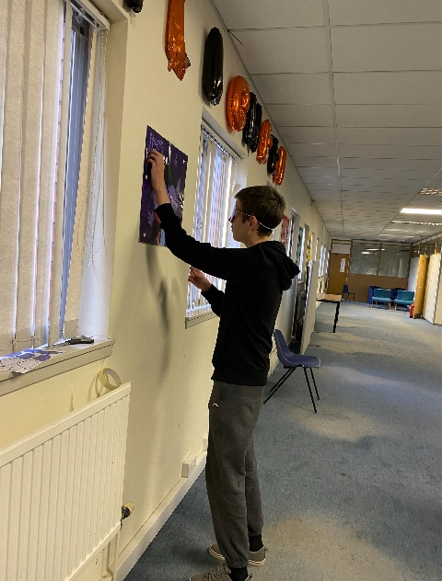This month the trainees upstairs on our NOLB FOCUS and NOLB ACCELERATE took part in various different activities for Halloween. This included pin the ears on the vampire which the trainees thoroughly enjoyed and also speedy spiders.

**Kyle Smith who is on our NOLB FOCUS enjoying pinning the ears on the vampire. He had a great time doing this.**

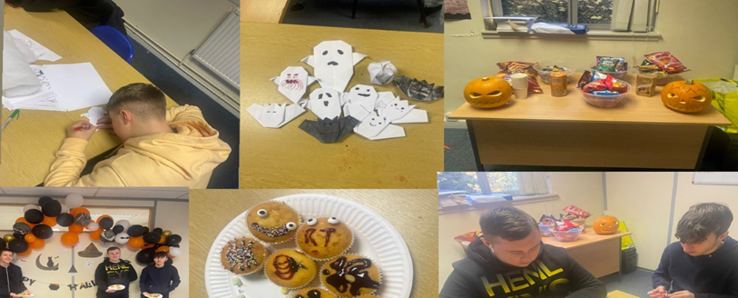

**This is the rest of our NOLB Focus and accelerate who enjoyed the decorating and sweet treats the best. Overall, I would say they had a great time and they said they would love to decorate for Christmas in the centre as well.**

**Halloween In Bridgeton**

**We also had some celebrations for Halloween in our Bridgeton centre.**

**This consisted of the kids making candy apples and having some fun coming into the centre dressed up in their costumes. They look like they had a great time!!!**

**Think we can all agree that the two girls’ costumes were amazing, and we are glad they were in the Halloween spirit.**

**Good days out**

**A member from our REACH service and the LP PN group had a great day out getting out of their comfort zone going to play adventure golf. Jamie and Nikola have become amazing friends and have enjoyed creating a bond in the centre. Thanks, Lesley, for these amazing photos of Jamie and Nikola.**

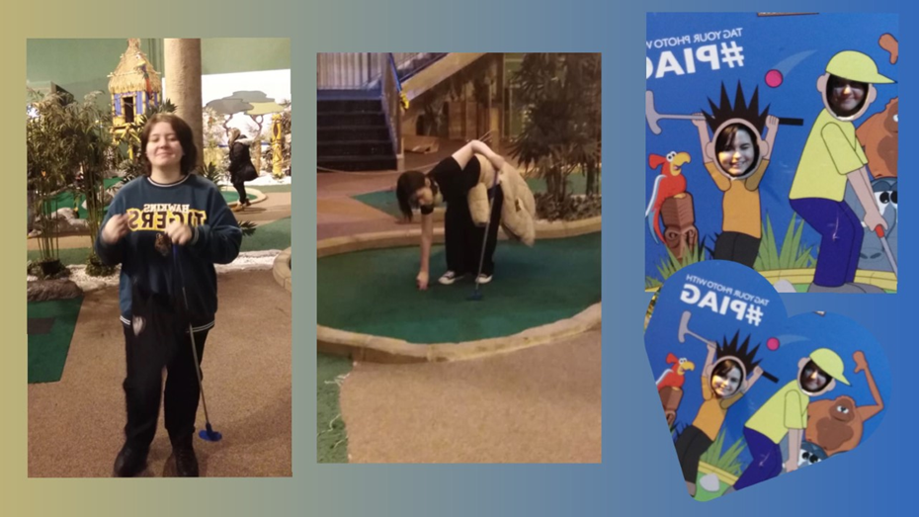

**They really enjoyed their day out at adventure golf, and they even got a little bit competitive. We are so proud of how far Jamie and Nikola have come and glad they are now comfortable in the centre and also out with the centre on trips.**

**Case Studies NOLB Focus, Lift off.**

**NOLB LIFT OFF**



**NOLB FOCUS**

Kyle came to Right Track when he left school in June of this year after he had finished his sixth year. He was extremely quiet and unsociable. Kyle had been attending school but throughout the pandemic his anxiey and social skills went downhill. Kyle was nervous about coming into centre and meeting new people. We worked with Kyle over the summer to build confidence and communication skills as Kyle was in no way ready to attempt work experience or to apply for job due to him lacking in social skills. Kyle started to gain confidence over this period in centre and also made new friends and became more sociable and confident while talking to staff and his peers.

At the beginning of September Kyle felt ready to move to our ESF ORBIT programme which was much more employability focussed with training sessions on employer expectations and workplace skills. Staff supported Kyle with his CV and he received one to one support with jobsearch activities. He registered with numerous job websites and learned how to apply in the correct manner. Kyle is liaising with our work experience co-ordinator to arrange a work placement. Now Kyle has moved over to our NOLB FOCUS program and has been working on applying for jobs and applying for college. We are so glad that kyle has came out of his comfort zone. Kyle likes to stay in routine and always comes in an hour early to start his day and does not like going out of this, although Kyle has improved we are still working with him to try show him that things can change easlily and that sometimes it can be a challenge. He will continue to liase with our work experience co – ordinator and help him find a placement that he will feel comfterable in and that he will be out of his comfort zone a little.

**NLB ACCELERATE**

Lewis Hutcheson started with us on NOLB ACCELERATE on the 03/10/2022. When Lewis came into the centre, he had a lot of confidence and was not shy atoll around staff and his peers. While being here he has participated in group projects that consisted of decorating the room and painting with his peers. Lewis gets along with everyone in the centre and loves to have a chat with everyone. While being on NOLB ACCELERATE he has achieved his ICT level 4 and is currently working on his employment skills. He has started to think what he would like to do with his future and is currently getting one to one support with his CV and help with looking at colleges and apprenticeships. Lewis had a Saturday job before coming to Right track and this helped him see that he would be interested in careers such as joinery and landscaping, so he has been researching about these sectors and learning what qualifications he would need for this and the skills that the employer would be looking for.

We are proud of how far Lewis has come due to his lack of qualifications and lack of willingness to learn as he is now eager to get out on placement and has been liaising with Morag our placement organizer to make this happen. We are hoping that as Lewis progresses that his CV will be fully updated with his skills and qualities that he has picked up while being a right track.

**PARTNERSHIPS**

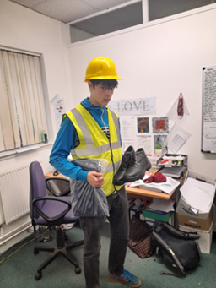**Trainees In placement**

Rowen Anderson who recently joined our NOLB FOCUS program went out on a work trial and smashed it. Rowen was really enjoying the placement and was even coming into centre after!! Rowen got offered the job and he was extremely happy. He started his new job on the 31/10/2022. We are so proud of you Rowen and we wish you the best in the future.

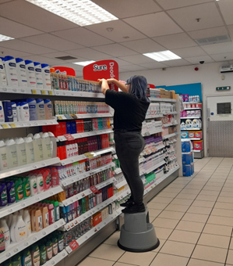Louise Weir who recently joined our NOLB FOCUS program started on her work experience in SAVERS. Louise is enjoying this placement and is loving learning all about retail. We are glad Louise is enjoying this and we are exited to see how she progresses in her new placement.

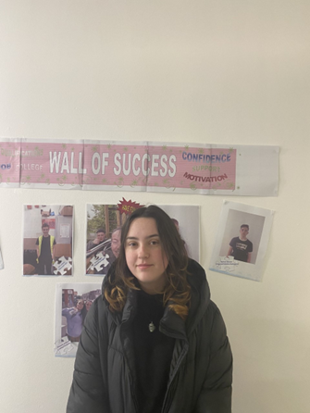Alyssa Mcquillan who also recently started on our NOLB FOCUS program has started a new placement at fish keepers Scotland. This is very out of her comfort zone, but she Is looking forward to learning new things and trying new things. We wish her the best in her placement and can’t wait to see how she progresses further with her new placement.

**Hall of Fame**

ESF LP BRIDGETON GRAHAM COLE PD self and work

CRF ACC COATBRIDGE JAMES LAFFERTY PD self in community

CRF ACC COATBRIDGE RACHAEL MCMILLAN PD self and work

CRF ACC COATBRIDGE DEAN CUMMINGS PD self in community

ESF ACC BRIDGETON LEON CORRIGAN PD self and work

CRF LIFT OFF COATBRIDGE CARYS GALLAGHER Core I.T.

CRF LIFT OFF COATBRIDGE DYLAN BROCK Core I.T.

ESF LP BRIDGETON COLE JACKSON NUMERACY LEVEL 3

ESF LP BRIDGETON EMILYLEE ORR NUMERACY LEVEL 4

ESF ACC BRIDGETON SOPHIE LINDSAY SELF AND WORK

ESF ACC BRIDGETON CASSIE CAVEN EXPLORING WELBEING

ESF LP COATBRIDGE ELLIE MAUGHAN CORE I.T.

ESF LP COATBRIDGE AARON BYRNE CORE I.T.

ESF LP COATBRIDGE BETHANY HOTSON CORE I.T.

ESF LP COATBRIDGE SCOTT MORTIMER CORE I.T.

CRF LIFT OFF COATBRIDGE FREDDIE GLEN CORE I.T.

ESF ORBIT COATBRIDGE ROWEN ANDERSON CUSTOMER CARE

ESF ORBIT COATBRIDGE KYLE SEDGEWORTH CUSTOMER CARE

ESF ORBIT COATBRIDGE CHANTELLE HARMON CUSTOMER CARE

ESF ORBIT COATBRIDGE ALYSSA MCQUILLAN CUSTOMER CARE

ESF ORBIT COATBRIDGE KYLE SMITH CUSTOMER CARE

ESF ORBIT COATBRIDGE GRACE DONNELLY CUSTOMER CARE

ESF ACC BRIDGETON DEAN ELDER SELF AND WORK

ESF ORBIT COATBRIDGE AIDEN HUGHES CUSTOMER CARE

NOLB FOCUS COATBRIDGE LOUISE WEIR PREPARING TO WORKESF LP COATBRIDGE DECLYN KEYES CORE I.T.

**Trainee of the Month - COATBRIDGE**

**Alyssa Mcquillan**

Alyssa who is on our NOLB FOCUS program has really grown since she started with us on our different programmes. When she first came to the centre, she was quiet, shy, and very nervous at participating in activities she is now taking active roles in group and leading projects. Her overall attendance on every program has been exceptional and so is her attitude, she will do anything that is asked of her and is happy to help her peers when required.  She has also secured a placement in Fish keepers Scotland and started there this week. Fish keepers Scotland is an aquarium like place where Alyssa will undertake tasks of cleaning tanks and serving customers and will also learn a lot more about fish. We are so proud of how far Alyssa has come and we wish her all the best in her placement journey.

**Congratulations**

**Alyssa Mcquillan**

**Coatbridge Trainee of the month**

**October 2022**

**Trainee of the month - BRIDGETON**

**Cassie Caven**

Cassie started on our Accelerate programme, she had major anxiety issues which were holding her back. It took 3 attempts to get Cassie to come for an interview, when she finally came her action children worker had to basically push her in to speak to me. She was very nervous throughout the interview, but I managed to talk her into giving us a chance and starting the programme. The first couple of weeks Cassie’s mum had to bring her to the door and put her in, Cassie started talking to one of my other girls who also suffers from anxiety they have now become friends. Cassie started to attend the centre herself which was also a big hurdle for her. Over the week’s Cassie was getting less anxious and more comfortable. I spoke to Cassie to see what career path she would like to pursue, and she told me about childcare. I helped Cassie to fill out an application to Carousel training she did an online application and sent it away. The following day Cassie got a reply asking her to come in for an interview on Monday 24th October. I got Cassie prepared for her interview she practices her personal statement that she needed to do for Carousel. Cassie went for her interview, and she has done extremely well they offered her the apprenticeship. Carousel set up a work trial with a nursery Cassie attended the trial and she has done excellent the feedback was great and the nursery wants her to do her apprenticeship with them. Cassie starts on Monday 7th November. Cassie has come a long way and she has done extremely well. If you had seen Cassie when she started and seen her know you wouldn’t believe the difference in her.

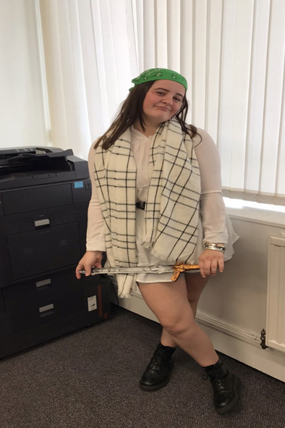**Congratulations**

**Cassie caven**

**Bridgeton trainee of the month**

**October 2022**