**Welcome to our September Newsletter…….**

***Time to have a catch up with***

***what has been going on in our Right Track Centres this month***

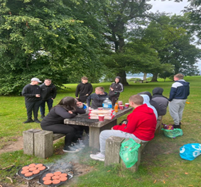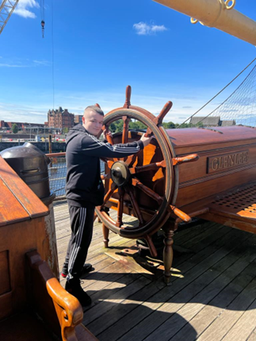

**Contents**

1. **The REACH Support Group**
2. **Contract Changes and our Programmes**
3. **A tribute to the late Queen**
4. **Hard work in September**
5. **Welcome to new staff**
6. **Hall of Fame**
7. **A good day out**

**The REACH Support Group**

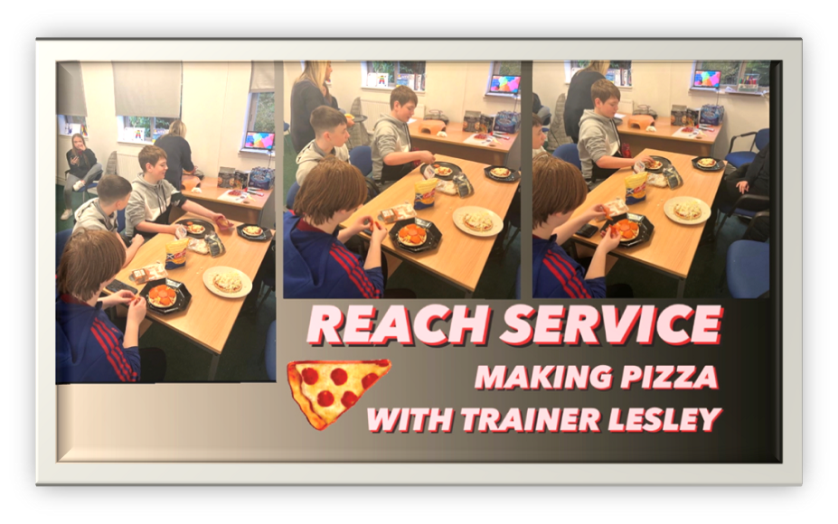

Our new REACH Support group launched in August and now has 11 participants. REACH offers support 3 days a week to young people with a variety of mental health support needs.

REACH is very inclusive, and our aims are simple; to support young people to feel safe, listened to, supported, cared for, understood, and not judged.

Ultimately, we want to help young people feel better about themselves as they take part in the Group. It is anticipated that changes achieved in REACH will support young people to move on to more structured Programmes and learning options.

Pizza was a big success, (thanks Lesley!), and a great teamworking exercise too!

Well done all!

 ***REACH***

**Contract Changes**

The 30th of September brought with it the end of our Community Renewal Fund Programmes, a UK Government Programme delivered in conjunction with North Lanarkshire Council.

Our CRF Lift Off, Accelerate and Touchdown Programmes have been running since December 21 and despite the short timescales have been very successful. Individual young person achievements have been featured in our monthly Newsletters highlighting young people progressing to a broad range of College Courses, accessing jobs as diverse as Waste Management and Multi-Media, taking part in a huge array of Work Experience Provision and young people of pre-school leaving age returning to mainstream education after periods of absence and engagement with our Lift Off Programme.

CRF Funding has also made a huge range of out of centre experiences possible for all our CRF participants. Examples include; speedboats on Loch Lomond, gorge-walking, paddle- boarding, mountain climbing, horse-riding, cooking, adventurous eating, afternoon tea, cinema trips, barbecues on the beach, bubble football, the list is endless. This huge variety, helps our young people to improve their confidence and self-esteem, try something new, have broadened horizons and the opportunity to excel in areas that they have never previously imagined. These activities are also about building an understanding of “team” and promoting use of initiative, while providing young people the opportunity to “lead” and help others.

While we are really proud of what the young people on our CRF Programmes achieved in relation to jobs, qualifications, progressions to higher level learning, re-engagement in School, participation in Work Experience, what is often under-reported, and yet equally important, is the “soft progressions” facilitated by the Programmes, measurements such as; improved confidence, improved self-esteem and self-worth, improved aspiration, increased happiness, new friendships, pride in achievement, improved appreciation of learning, improved coping skills, improved willingness to try something new, improved communication and willingness to listen to advice and follow instructions, indeed, improved “lifeskills” in the broadest sense. We are confident that all young people who took part in our CRF Programmes experienced, being supported, listened to, motivated and encouraged.

We are delighted to announce that following the cessation of our CRF Programmes we will launch new Lift Off and Accelerate and FOCUS Programmes on 1 October 22, again in partnership with North Lanarkshire Council, funded via their No One Left Behind Budget. We look forward to the positive delivery of these Projects and being able to report on the highlights in future Newsletters.

In the interim, can I say Thank You, to Yvonne, Mark and Duncan at North Lanarkshire Council for their robust CRF support and patience in relation to some of my more trying queries! Hugely appreciated.

**Our Programmes**

**Lift Off (Coatbridge)**

Lift Off offers a Programme of support to young people, 15/16 years, who are not flourishing within mainstream education and have 6 months or less before they reach their official school leaving date.

Lift Off is offered from our Coatbridge Training Centre. Young people are supported via small group-work and one to one support. We offer access to Digital, Personal Development and Core Skill support alongside intensive personal goal-setting and Key Worker support.

Lift Off offers a broad range of out of centre activities, visits, sports introductions, practical projects and outdoor challenge activities.

Young people will be offered the opportunity to achieve SQA Awards in Personal Development, Customer Service and Digital Skills

Young people will receive Travel Costs and Lunch.

Referrals can be made directly from Schools/ Careers staff.

**REACH (Coatbridge and Bridgeton)**

REACH is our Mental Health Support Project supporting young people aged 15-18 years suffering from the impact of a range of mental health challenges. The Project offers one to one support, support from CBT Practitioners, access to alternative therapies, upcycling, introductions to sports, dance, cooking and creative arts, crafts, music making activities, yoga, Tai Chi and many other interventions.

Our sole aim at REACH is to support young people to start to feel better about themselves and to start to develop coping skills and strategies.

Young people will receive a daily Participation Payment, Travel Costs and Lunch.

Referrals can be made from Schools, Social Work, Training Providers/ Colleges/ Careers staff, GPs, other Voluntary Sector support agencies, parents/ guardians or self-referrals.

**Pre-NEET Launchpad (Coatbridge and Bridgeton)**

This Programme offers a Programme of alternative learning for young people with 6 months or less before they can officially leave School.

Pre-NEET Launchpad is offered from our Coatbridge Training Centre. Young people are supported via small group-work and one to one support. We offer access to Digital, Personal Development and Core Skill support alongside intensive personal goal-setting and Key Worker support.

Pre-NEET Launchpad offers a broad range of out of centre activities, visits, sports introductions, practical projects, and outdoor challenge activities.

Young people will be offered the opportunity to achieve SQA Awards in Personal Development, Customer Service and Digital Skills

Young people will receive a Training Allowance, Travel Costs and Lunch.

Referrals can be made directly from Schools/ Careers staff

**LAUNCHPAD – Stage 1 (Coatbridge and Bridgeton)**

Launchpad, as described above is for young people who have reached their official school leaving date

For 16-18 year olds, Launchpad slowly introduces an Employability focus but still offers a high degree of out of centre activities designed to support Personal Development and Lifeskills progress.

Young people will be offered the opportunity to achieve SQA Awards in Personal Development, Customer Service and Digital Skills.

Young people will receive a Training Allowance, Travel Costs and Lunch.

Referrals can be made directly from Schools/ Careers staff, other Training Providers/ Voluntary Sector Organisations.

**Accelerate – Stage 2 (Coatbridge and Bridgeton)**

Accelerate is for young people aged 16-19 years.

Accelerate offers a range of Vocational Introductions alongside an intensive Personal Development Programme designed to help young people recognise the need for Digital, Core and Personal skills in everyday life and work situations.

Vocational understanding is enhanced by access to Virtual Reality experiences offering young people an insight into various occupations and helping them interact in Customer Service occupations.

Young people will be offered the opportunity to achieve SQA Awards in Personal Development, Customer Service and Digital Skills

Young people will receive a Training Allowance, Travel Costs and Lunch.

Referrals can be made directly from Schools/ Careers staff, other Training Providers/ Voluntary Sector Organisations.

**FOCUS – Stage 3 (Coatbridge)**

FOCUS is a Stage 3 opportunity offering intensive Employability and Jobsearch support, followed by Work Experience/ Work Trial.

Young people are also offered access to industry-specific accreditation such as CSCS card, REHIS Food Hygiene and First Aid.

FOCUS participants are offered a Training Allowance and Travel assistance, alongside any clothes/ boots for work, as needed.

Referrals can be made by Schools, Careers staff, Training Providers/ Voluntary Sector organisations/ Self-referral

**Should you require further information on any of these Programmes, please contact; Ann or Tracey on 01236-433315 or Jackie or Jim on 0141-554-0955**

**A tribute to the late Queen**



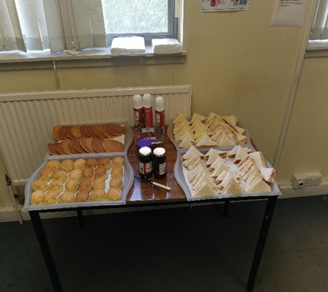

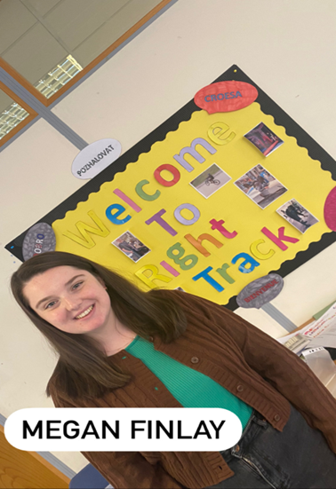**A Warm Welcome to our new staff**

**Megan**

Megan has joined our team after graduating from University with her Community Education Degree and some experience in Community Youth Work. Right Track is a very different environment for Megan, but she has settled in well and is definitely improving in confidence and finding her feet! It is fair to say Megan has entered at the deep end and has already taken part in trips with the young people and led on a staff training event piloting new voice technology. In her spare time Megan enjoys Netflix and comfort food! I am sure she needs to relax after her first weeks at Right Track. Megan has so far been a valued addition to our team.

**WELCOME TO THE TEAM MEGAN!!!!!** **Gerry**

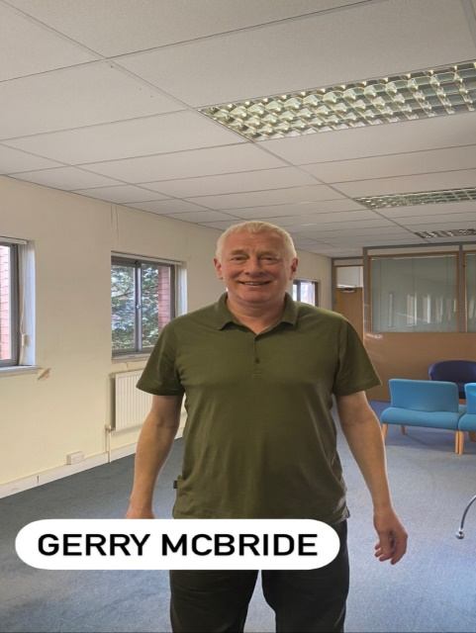Gerry has recently joined our team having previously worked for Rathbone Training between 2014 and 2019 doing a similar job to this one, working with young people on Employability Skills and Core Skills. Before this he worked for the University of Glasgow as an IT trainer. He delivered training to various client groups from Modern Apprentices and University staff working towards the European Computer Driving Licence (ECDL) to private clients learning to build basic websites using Adobe software. We are advised that Gerry was “coaxed” out of semi-retirement to join us, but we are very glad he decided to do so and with all his prior experience, he has hit the ground running!

**THANKS, AND WELCOME GERRY!**



**Hard Work in September!**





**Hall of Fame**

Neo Hastie – CRF ACCELERATE – Coatbridge – Core I.T

Aidan Shields – CRF ACCELERATE – Coatbridge – Core I.T

David Smith – TOUCHDOWN – Coatbridge – PD Self and Work

Christopher Smith – CRF ACCELERATE – Coatbridge – Core I.T

Alfie Watterson – CRF LIFT OFF – Coatbridge – Core I.T

Caden Rowe – CRF LIFT OFF – Coatbridge – Core I.T

Melissa Drain – CRF LIFT OFF – Coatbridge – Core I.T

Reece Gorman – CRF ACCELERATE – Coatbridge – Core I.T

Hannah Gibson – CRF LIFT OFF – Coatbridge – Core I.T

Lynn McGrath – CRF LIFT OFF – Coatbridge – Core I.T

Kori Meikle – CRF LIFT OFF – Coatbridge – Core I.T

Scarlett Campbell – CRF LIFT OFF – Coatbridge – Core I.T

Rhys Yule Ramage - CRF LIFT OFF – Coatbridge – Core I.T

**Good Days Out!**

The Lift Off Group has enjoyed some really good days out this month but the gorge-walking at the Devil’s Pulpit was the most popular, closely followed by the Transport Museum! It is fair to say the trip to the Transport Museum was less wet!!!

**Gorge-walking**

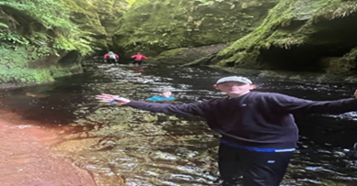  
**Transport Museum**

**Good Days Out!**



[This Photo](https://pchujman.cumbresblogs.com/2020/08/07/songs-to-protest/) by Unknown Author is licensed under [CC BY](https://creativecommons.org/licenses/by/3.0/)

**This project is part funded by the UK Government through the**

**UK Community Renewal Fund**

*The UK Community Renewal Fund is a UK Government programme for 2021/22. This aims to support people and communities in need across the UK to pilot programmes and new approaches to prepare the UK for the Shared Prosperity Fund. It invests in skills, community and place, local business, and supporting people in employment. For more information, visit* [*https://www.gov.uk/government/publications/uk-community-renewal-fund-prospectus*](https://www.gov.uk/government/publications/uk-community-renewal-fund-prospectus)

